Aim of the Project
The goal of this project was to design an interactive and visually appealing online portfolio that effectively presents my skills, projects, and professional journey. The website serves as a digital showcase, making it easier for potential employers and collaborators to explore my expertise in web development, data science, and artificial intelligence.
Methodology Used
The development process followed a structured workflow:
- Planning & Research – Defining core sections such as About Me, Projects, Certifications, and Contact.
- Design Phase – Creating wireframes and selecting a modern, user-friendly layout.
- Development – Implementing the site using HTML, CSS, and JavaScript, ensuring responsiveness.
- Testing & Optimization – Conducting cross-browser testing and refining UI elements.
- Deployment – Hosting the static version on GitHub Pages for easy accessibility.
Tools Used
- Frontend Technologies – HTML5, CSS3, JavaScript for structure, styling, and interactivity.
- UI Enhancements – ScrollReveal for animations, Google Fonts for typography, Boxicons for icons.
- Development & Hosting – GitHub Pages for deployment, Git for version control.
- Testing – XAMPP for local server simulation and browser compatibility checks.

Program code:
#index.html
<!DOCTYPE html>
<html lang="en">
<head>
<title>My Portfolio</title>
<meta name="viewport" content="width=device-width,initial-scale=1">
<link rel="stylesheet" href="style.css">
</head>
<body>
<div class="main">
<div class="navbar">
<img src="logo.png" class="logo">
<ul>
<li><a href="index.html">HOME</a></li>
<li><a href="about.html">ABOUT</a></li>
<li><a href="education.html">EDUCATION</a></li>
<li><a href="certificate.html">CERTIFICATES</a></li>
<li><a href="projects.html">MY WORKS</a></li>
<li><a href="contact.php">CONTACT</a></li>
</ul>
</div>
<div class="info">
<h3>Hi, I'm <span>Udaiyanethi</span>.</h3>
<h1><span>A</span>SPIRING <span>S</span>OFTWARE ENGINEER</h1>
<h3>Passionate about coding, learning new technologies, and building cool projects.</h3>
<a href="#">Hire Me</a>
</div>
<div class="image">
<img src="profile.png" class="boy">
</div>
<div class="icons">
<a href="#"><ion-icon name="logo-facebook"></ion-icon></a>
<a href="#"><ion-icon name="logo-instagram"></ion-icon></a>
<a href="#"><ion-icon name="logo-twitter"></ion-icon></a>
</div>
</div>
<script src="https://unpkg.com/ionicons@5.4.0/dist/ionicons.js"></script>
</body>
</html>

#about.html
<!DOCTYPE html>
<html lang="en">
<head>
<meta charset="UTF-8">
<meta name="viewport" content="width=device-width, initial-scale=1.0">
<title>About Me</title>
</head>
<body style="font-family: Arial, sans-serif; margin: 0; padding: 0; background-color: #f4f4f4;">
<header style="display: flex; justify-content: space-between; align-items: center; padding: 15px 50px; background: #222; color: white;">
<img src="logo.png" alt="Logo" class="logo" style="width: 100px; height: auto;">
<nav>
<ul style="list-style: none; display: flex; gap: 25px; margin: 0; padding: 0;">
<li><a href="index.html" style="color: white; text-decoration: none; font-size: 18px; transition: 0.3s;" onmouseover="this.style.color='rgb(230,104,59)'" onmouseout="this.style.color='white'">HOME</a></li>
<li><a href="about.html" style="color: white; text-decoration: none; font-size: 18px; transition: 0.3s;" onmouseover="this.style.color='rgb(230,104,59)'" onmouseout="this.style.color='white'">ABOUT</a></li>
<li><a href="education.html" style="color: white; text-decoration: none; font-size: 18px; transition: 0.3s;" onmouseover="this.style.color='rgb(230,104,59)'" onmouseout="this.style.color='white'">EDUCATION</a></li>
<li><a href="certificate.html" style="color: white; text-decoration: none; font-size: 18px; transition: 0.3s;" onmouseover="this.style.color='rgb(230,104,59)'" onmouseout="this.style.color='white'">CERTIFICATES</a></li>
<li><a href="projects.html" style="color: white; text-decoration: none; font-size: 18px; transition: 0.3s;" onmouseover="this.style.color='rgb(230,104,59)'" onmouseout="this.style.color='white'">MY WORKS</a></li>
<li><a href="contact.php" style="color: white; text-decoration: none; font-size: 18px; transition: 0.3s;" onmouseover="this.style.color='rgb(230,104,59)'" onmouseout="this.style.color='white'">CONTACT</a></li>
</ul>
</nav>
</header>
<section class="about" style="padding: 60px; text-align: center; background: linear-gradient(to bottom,#d19185, #fd6e6e); color: white;">
<h1 style="font-size: 35px; margin-bottom: 10px;">Udaiyanethi S</h1>
<p style="font-size: 20px; font-weight: bold;">Developer | Data Analyst</p>
<p style="max-width: 800px; margin: auto; line-height: 1.6; font-size: 18px;">I am passionate about exploring the world of Data Analytics and Artificial Intelligence. As I continue my journey, I am focused on mastering data-driven decision-making using machine learning, deep learning, and business intelligence tools. My goal is to extract meaningful insights and solve real-world challenges.</p>
<p style="max-width: 800px; margin: auto; line-height: 1.6; font-size: 18px;">Currently, I am honing my skills in Python, SQL, and Watson, which are essential for data analytics and AI. I enjoy working with large datasets, performing data cleaning and transformation, and building predictive models to drive data-driven strategies.</p>
<p style="max-width: 800px; margin: auto; line-height: 1.6; font-size: 18px;">Through hands-on projects and internships, I have gained experience in data preprocessing, feature engineering, data visualization, and developing machine learning models.</p>
<p style="max-width: 800px; margin: auto; line-height: 1.6; font-size: 18px;">I am eager to keep learning, growing, and working on projects that contribute to the future of AI and data science.</p>
</section>
<footer style="text-align: center; padding: 15px; background: #222222; color: white;">
<p>© 2025 My Portfolio | Udaiya</p>
</footer>
</body>
</html>

#education.html
<!DOCTYPE html>
<html lang="en">
<head>
<meta charset="UTF-8">
<meta name="viewport" content="width=device-width, initial-scale=1.0">
<title>Certificate</title>
</head>
<body style="font-family: Arial, sans-serif; margin: 0; padding: 0; background-color: #f4f4f4;">
<header style="display: flex; justify-content: space-between; align-items: center; padding: 15px 50px; background: #222; color: white;">
<img src="logo.png" alt="Logo" class="logo" style="width: 100px; height: auto;">
<nav>
<ul style="list-style: none; display: flex; gap: 25px; margin: 0; padding: 0;">
<li><a href="index.html" style="color: white; text-decoration: none; font-size: 18px; transition: 0.3s;" onmouseover="this.style.color='rgb(230,104,59)'" onmouseout="this.style.color='white'">HOME</a></li>
<li><a href="about.html" style="color: white; text-decoration: none; font-size: 18px; transition: 0.3s;" onmouseover="this.style.color='rgb(230,104,59)'" onmouseout="this.style.color='white'">ABOUT</a></li>
<li><a href="education.html" style="color: white; text-decoration: none; font-size: 18px; transition: 0.3s;" onmouseover="this.style.color='rgb(230,104,59)'" onmouseout="this.style.color='white'">EDUCATION</a></li>
<li><a href="certificate.html" style="color: white; text-decoration: none; font-size: 18px; transition: 0.3s;" onmouseover="this.style.color='rgb(230,104,59)'" onmouseout="this.style.color='white'">CERTIFICATES</a></li>
<li><a href="projects.html" style="color: white; text-decoration: none; font-size: 18px; transition: 0.3s;" onmouseover="this.style.color='rgb(230,104,59)'" onmouseout="this.style.color='white'">MY WORKS</a></li>
<li><a href="contact.php" style="color: white; text-decoration: none; font-size: 18px; transition: 0.3s;" onmouseover="this.style.color='rgb(230,104,59)'" onmouseout="this.style.color='white'">CONTACT</a></li>
</ul>
</nav>
</header>
<section class="department" style="padding: 60px; text-align: center; background: linear-gradient(to bottom, #d19185, #fd6e6e); color: white;">
<h1 style="font-size: 40px; margin-bottom: 20px;">Education Details</h1>
</section>
<section style="display: flex; flex-wrap: wrap; justify-content: center; padding: 40px; background: #141414;">
<div style="max-width: 900px;">
<div style="background: white; padding: 20px; margin-bottom: 20px; border-radius: 10px; box-shadow: 0 4px 8px rgba(0, 0, 0, 0.1);">
<h3>Bachelor of Technology in Computer Science Engineering with Data Science & Artificial</h3>
<p>Dr.M.G.R Educaton and Research Institute | 2022 - 2026(ongoing)</p>
</div>
<div style="background: white; padding: 20px; margin-bottom: 20px; border-radius: 10px; box-shadow: 0 4px 8px rgba(0, 0, 0, 0.1);">
<h3>High School</h3>
<p>The Ashram Mat.H.S.S | 2020 - 2022</p>
</div>
</section>
<footer style="text-align: center; padding: 15px; background: #222; color: white;">
<p>© 2025 My Portfolio | Udaiya</p>
</footer>
</body>
</html>

#certificate.html
<!DOCTYPE html>
<html lang="en">
<head>
<meta charset="UTF-8">
<meta name="viewport" content="width=device-width, initial-scale=1.0">
<title>Certificate</title>
</head>
<body style="font-family: Arial, sans-serif; margin: 0; padding: 0; background-color: #f4f4f4;">
<header style="display: flex; justify-content: space-between; align-items: center; padding: 15px 50px; background: #222; color: white;">
<img src="logo.png" alt="Logo" class="logo" style="width: 100px; height: auto;">
<nav>
<ul style="list-style: none; display: flex; gap: 25px; margin: 0; padding: 0;">
<li><a href="index.html" style="color: white; text-decoration: none; font-size: 18px; transition: 0.3s;" onmouseover="this.style.color='rgb(230,104,59)'" onmouseout="this.style.color='white'">HOME</a></li>
<li><a href="about.html" style="color: white; text-decoration: none; font-size: 18px; transition: 0.3s;" onmouseover="this.style.color='rgb(230,104,59)'" onmouseout="this.style.color='white'">ABOUT</a></li>
<li><a href="education.html" style="color: white; text-decoration: none; font-size: 18px; transition: 0.3s;" onmouseover="this.style.color='rgb(230,104,59)'" onmouseout="this.style.color='white'">EDUCATION</a></li>
<li><a href="certificate.html" style="color: white; text-decoration: none; font-size: 18px; transition: 0.3s;" onmouseover="this.style.color='rgb(230,104,59)'" onmouseout="this.style.color='white'">CERTIFICATES</a></li>
<li><a href="projects.html" style="color: white; text-decoration: none; font-size: 18px; transition: 0.3s;" onmouseover="this.style.color='rgb(230,104,59)'" onmouseout="this.style.color='white'">MY WORKS</a></li>
<li><a href="contact.php" style="color: white; text-decoration: none; font-size: 18px; transition: 0.3s;" onmouseover="this.style.color='rgb(230,104,59)'" onmouseout="this.style.color='white'">CONTACT</a></li>
</ul>
</nav>
</header>
<section class="department" style="padding: 60px; text-align: center; background: linear-gradient(to bottom, #d19185, #fd6e6e); color: white;">
<h1 style="font-size: 40px; margin-bottom: 20px;">Department Events and Certifications</h1>
</section>
<section style="display: flex; flex-wrap: wrap; justify-content: center; padding: 40px; background: #141414;">
<div style="max-width: 900px;">
<div style="background: white; padding: 20px; margin-bottom: 20px; border-radius: 10px; box-shadow: 0 4px 8px rgba(0, 0, 0, 0.1);">
<h3>IBM Certificates</h3>
<p>✅ Python Certification: Completed Python Basics</p>
<p>✅ Java Certification: Completed Java Basics</p>
<p>✅ Cloud Application Developer Certification</p>
<p>✅ Business Intelligence using Cognos Certification</p>
</div>
<div style="background: white; padding: 20px; margin-bottom: 20px; border-radius: 10px; box-shadow: 0 4px 8px rgba(0, 0, 0, 0.1);">
<h3>NPTEL Certificate</h3>
<p>✅ Python for DataScience</p>
</div>
</section>
<footer style="text-align: center; padding: 15px; background: #222; color: white;">
<p>© 2025 My Portfolio | Udaiya</p>
</footer>
</body>
</html>

#projects.html
<!DOCTYPE html>
<html lang="en">
<head>
<meta charset="UTF-8">
<meta name="viewport" content="width=device-width, initial-scale=1.0">
<title>Projects</title>
</head>
<body style="font-family: Arial, sans-serif; margin: 0; padding: 0; background-color: #f4f4f4;">
<header style="display: flex; justify-content: space-between; align-items: center; padding: 15px 50px; background: #222; color: white;">
<img src="logo.png" alt="Logo" class="logo" style="width: 100px; height: auto;">
<nav>
<ul style="list-style: none; display: flex; gap: 25px; margin: 0; padding: 0;">
<li><a href="index.html" style="color: white; text-decoration: none; font-size: 18px; transition: 0.3s;" onmouseover="this.style.color='rgb(230,104,59)'" onmouseout="this.style.color='white'">HOME</a></li>
<li><a href="about.html" style="color: white; text-decoration: none; font-size: 18px; transition: 0.3s;" onmouseover="this.style.color='rgb(230,104,59)'" onmouseout="this.style.color='white'">ABOUT</a></li>
<li><a href="education.html" style="color: white; text-decoration: none; font-size: 18px; transition: 0.3s;" onmouseover="this.style.color='rgb(230,104,59)'" onmouseout="this.style.color='white'">EDUCATION</a></li>
<li><a href="certificate.html" style="color: white; text-decoration: none; font-size: 18px; transition: 0.3s;" onmouseover="this.style.color='rgb(230,104,59)'" onmouseout="this.style.color='white'">CERTIFICATES</a></li>
<li><a href="projects.html" style="color: white; text-decoration: none; font-size: 18px; transition: 0.3s;" onmouseover="this.style.color='rgb(230,104,59)'" onmouseout="this.style.color='white'">MY WORKS</a></li>
<li><a href="contact.php" style="color: white; text-decoration: none; font-size: 18px; transition: 0.3s;" onmouseover="this.style.color='rgb(230,104,59)'" onmouseout="this.style.color='white'">CONTACT</a></li>
</ul>
</nav>
</header>
<section class="department" style="padding: 60px; text-align: center; background: linear-gradient(to bottom, #d19185, #fd6e6e); color: white;">
<h1 style="font-size: 40px; margin-bottom: 20px;">My Works</h1>
</section>
<section style="display: flex; flex-wrap: wrap; justify-content: center; padding: 40px; background: #fff;">
<div style="max-width: 900px;">
<div style="background: white; padding: 20px; margin-bottom: 20px; border-radius: 10px; box-shadow: 0 4px 8px rgba(0, 0, 0, 0.1);">
<h3>Tic-Tac-Toe</h3>
<p>Built a web-based game with HTML, CSS, JavaScript, and Firebase for real-time play.</p>
</div>
<div style="background: white; padding: 20px; margin-bottom: 20px; border-radius: 10px; box-shadow: 0 4px 8px rgba(0, 0, 0, 0.1);">
<h3>Disaster Management Analysis</h3>
<p>Used IBM Cognos to analyze disaster data and generate reports.</p>
</div>
<div style="background: white; padding: 20px; margin-bottom: 20px; border-radius: 10px; box-shadow: 0 4px 8px rgba(0, 0, 0, 0.1);">
<h3>Chatbot Development </h3>
<p>Developed an AI chatbot using IBM Watson for user query handling.</p>
</div>
</div>
</section>
<footer style="text-align: center; padding: 15px; background: #222; color: white;">
<p>© 2025 My Portfolio | Udaiya</p>
</footer>
</body>
</html>

#style.css
*{
margin: 0;
padding: 0;
}
.main{
width: 100%;
background: url(pic/bg.jpg);
background-position: center;
background-size: cover;
height: 100vh;
position: relative;
font-family: sans-serif;
}
.navbar{
width: 86%;
display: flex;
margin: auto;
padding: 15px 0;
align-items: center;
justify-content: space-between;
}
.navbar .logo{
width: 160px;
cursor: pointer;
margin-top: -3%;
margin-left: -2%;
}
ul{
margin-top: -4%;
}
ul li{
list-style: none;
display: inline-block;
padding: 10px 16px;
}
ul li a{
font-size: 16px;
font-weight: bold;
text-decoration: none;
color: darkslategray;
margin-top: -3%;
transition: .4s ease;
}
ul li a:hover{
color: rgb(230,104,59);
}
.info{
margin-left: 7%;
margin-top: 6%;
}
.info h1{
font-size: 65px;
color: rgb(36,32,30);
}
.info h3{
font-size: 18px;
letter-spacing: 1px;
line-height: 24px;
}
.info span{
color: rgb(230,104,59);
}
.info a{
text-decoration: none;
color: #fff;
background: rgb(36,32,30);
margin: 26px 0;
padding: 10px 18px;
border-radius: 10px;
display: inline-block;
transition: .4s ease;
}
.info a:hover{
background: rgb(59,174,209);
}
.image{
width: 30%;
height: 60%;
position: absolute;
right: 100px;
bottom: 0;
}
.image img{
position: absolute;
height: 140%;
left: 40%;
transform: translate(-55%);
bottom: 0;
transition: left 2s ease;
}
.image:hover .boy{
left: 55%;
}
.icons a{
text-decoration: none;
color: #000;
}
.icons ion-icon{
margin-left: 7%;
color: #000;
margin-right: -60px;
font-size: 40px;
transition: .4s ease;
}
.icons ion-icon:hover{
color: rgb(59,174,209);
}

#contact.php
<!DOCTYPE html>
<html lang="en">
<head>
<meta charset="UTF-8">
<meta name="viewport" content="width=device-width, initial-scale=1.0">
<title>Contact Me</title>
<style>
body {
background-color: #121212;
color: #ffffff;
font-family: 'Poppins', sans-serif;
margin: 0;
padding: 0;
}
header {
display: flex;
justify-content: space-between;
align-items: center;
padding: 15px 50px;
background: #222;
color: white;
}
header .logo {
width: 100px;
height: auto;
}
header nav ul {
list-style: none;
display: flex;
gap: 25px;
margin: 0;
padding: 0;
}
header nav ul li a {
color: white;
text-decoration: none;
font-size: 18px;
transition: 0.3s;
}
header nav ul li a:hover {
color: rgb(230,104,59);
}
.contact-container {
background-color: #1e1e1e;
padding: 20px;
border-radius: 10px;
box-shadow: 0 0 10px rgba(255, 255, 255, 0.1);
text-align: center;
width: 350px;
margin: 50px auto;
}
input, textarea {
width: 100%;
padding: 10px;
margin: 10px 0;
background-color: #2a2a2a;
border: none;
color: #ffffff;
border-radius: 5px;
}
button {
background-color: #ff5722;
color: white;
border: none;
padding: 10px 15px;
width: 100%;
cursor: pointer;
border-radius: 5px;
transition: 0.3s;
}
button:hover {
background-color: #e64a19;
}
</style>
</head>
<body>
<header>
<img src="logo.png" alt="Logo" class="logo">
<nav>
<ul>
<li><a href="index.html">HOME</a></li>
<li><a href="about.html">ABOUT</a></li>
<li><a href="education.html">EDUCATION</a></li>
<li><a href="certificate.html">CERTIFICATES</a></li>
<li><a href="projects.html">MY WORKS</a></li>
<li><a href="contact.php">CONTACT</a></li>
</ul>
</nav>
</header>
<div class="contact-container">
<h2>Contact Me</h2>
<form action="" method="post">
<input type="text" name="name" placeholder="Your Name" required>
<input type="email" name="email" placeholder="Your Email" required>
<textarea name="message" placeholder="Your Message" required></textarea>
<button type="submit" name="submit">Send Message</button>
</form>
<p><?php echo $response ?? ''; ?></p>
</div>
</body>
</html>
<?php
// Handle form submission
if ($_SERVER["REQUEST_METHOD"] == "POST") {
$name = htmlspecialchars($_POST["name"]);
$email = htmlspecialchars($_POST["email"]);
$message = htmlspecialchars($_POST["message"]);

// Simple validation
if (!empty($name) && !empty($email) && !empty($message)) {
$response = "Thank you, $name! Your message has been received.";
} else {
$response = "Please fill in all fields!";
}
}
?>

Output

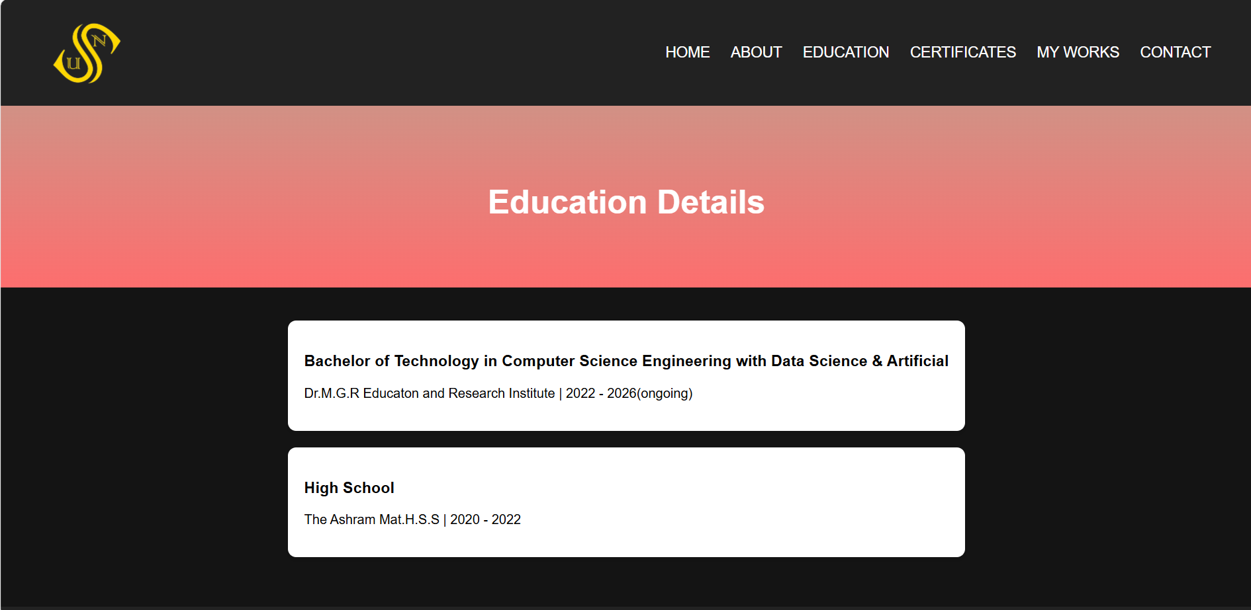
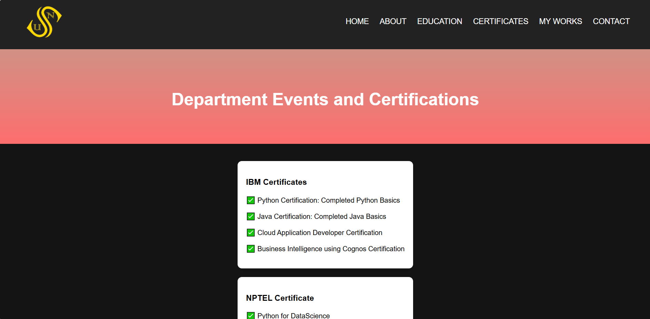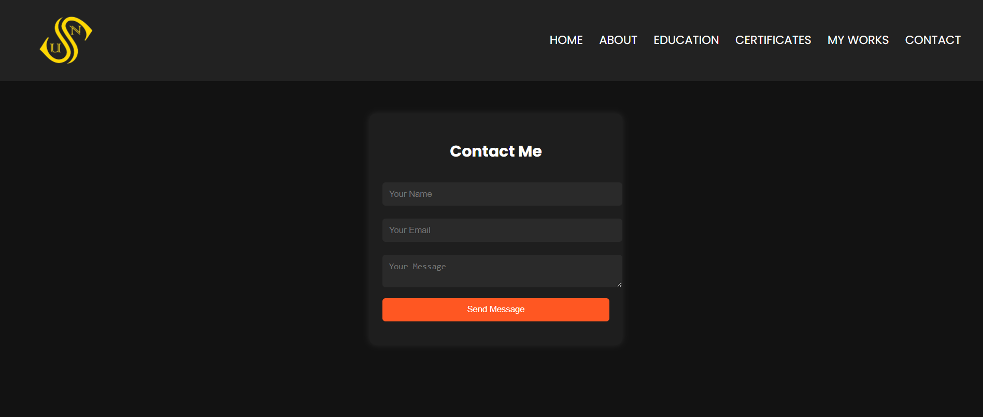

Results & Learning Outcomes
- Gained hands-on experience in UI/UX design and responsive web development.
- Strengthened knowledge in JavaScript for interactive features like smooth scrolling and animations.
- Developed a structured approach to project deployment and version control.
- Improved understanding of accessibility and mobile-friendly design.

